**Chapter 3**

**3.1 Algorithm**

3.1.1 algorithm of parameter measurement system

1. Initialization:

* Initialize the system, including the Arduino Mega and peripheral devices.
* Set up the LCD display for real-time information.

1. Sensor Monitoring:

* Continuously monitor the following sensors:
* Load sensor
* Flame sensor
* Temperature sensor

1. Sensor Fault Check:

* Check for sensor faults:
* If any sensor detects an issue, proceed to error handling.

1. Voice Command Detection:

* Utilize the voice recognition module to listen for voice commands from users.

1. Voice Command Processing:

* Process the recognized voice command:
* Identify the floor to which the user wants to go.
* Translate the voice command into a numerical floor selection.

1. Display Selection:

* Display the selected floor on the LCD for user confirmation.

1. Elevator Motor Operation:

* Control the DC motor to move the elevator to the selected floor:
* Adjust the motor's direction and movement.
* Announce the selected floor using the audio player module.

1. Manual Input Check:

* Continuously monitor for manual inputs, such as physical switches and IR sensors.

1. Manual Input Handling:

* If manual input is detected, adjust elevator operation based on the input.

1. Status Update:

* Continuously update the LCD display with the current system status.

1. Error Handling:

* If a sensor fault occurs:
* Display an error message on the LCD.
* Stop the elevator motor for safety.

1. Cloud Communication:

* Use the ESP8266 module to establish a connection with the cloud platform.

1. Data Transmission:

* Send relevant data to the cloud for remote monitoring and storage.

1. End:

* The software's main loop continues, ensuring uninterrupted operation.

**3.2 flowchart**

3.2.1 flowchart of parameter measurement system

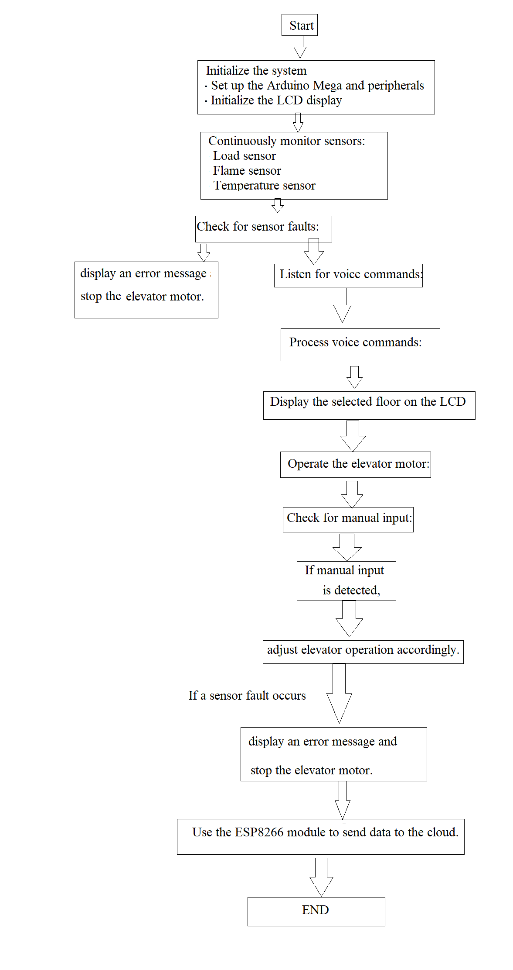

Fig.24: flowchart of parameter measurement system

**Chapter 4**

**4.1 Advantages**

1. User-Friendly: Voice control enhances user experience, making elevator operation more intuitive.
2. Safety: Integration of sensors ensures passenger safety by monitoring load, fire, and motor temperature.
3. Error Handling: Immediate response to sensor faults prevents potential accidents.
4. Auditory Feedback: Audible announcements of selected floors improve accessibility.
5. Remote Monitoring: Cloud connectivity enables remote monitoring and data transmission for efficient maintenance.

**4.2 disadvantages:**

1. Complexity: Implementing voice recognition and multiple sensors can add complexity to the system.
2. Maintenance: Advanced features may require more maintenance and troubleshooting.
3. Cost: The additional components and technology can increase the overall cost of the system.
4. Dependency on Technology: System functionality may be compromised during technical failures.
5. User Adaptation: Users may need time to adapt to voice commands and auditory feedback.

**4.3 Applications:**

1. Commercial Buildings: Ideal for enhancing elevator systems in office buildings, hotels, and shopping centers.
2. Hospitals: Ensures efficient and safe movement of patients and medical staff.
3. Residential Buildings: Can be implemented in modern residential complexes for convenience and safety.
4. Public Transport: Could be used in automated people movers and public transportation systems.
5. Smart Cities: Part of smart city infrastructure, improving transportation efficiency and safety.

**Chapter 5**

**Conclusion:**

In summary, the Voice-Operated Lift Control System combines user-friendly features, safety mechanisms, and cloud connectivity. It offers convenience but may require occasional maintenance and adaptation from users. Its potential applications range from commercial buildings to smart cities, making it a promising advancement in elevator technology.

**Chapter 6**

**References:**

[1] Lawrence Rabiner and Juang, Biing-Hwang. Fundamentals of Speech Recognition. United State: Prentice-Hall. 1993.

[2] Malvino, Albert Paul. Principles of Electronic Volume 2. New York: Salemba Teknika. 2004.

[3] M. Fugayama. Objects transfer robot arm control with Shape Similarity Using Kinematics Analysis. Thesis Program S1 Electrical Engineering University of Sam Ratulangi. Manado, 2011

. [4] O. Katsuhiko. Automatic Control Engineering (System Settings). Erland, Jakarta,1998.

[5] PM Dwisnanto. Design of intelligent Robot Ants Using Microcontroller AVR ATMEGA 16 to determine the shortest track. Thesis S1 Electrical Engineering University of Sam Ratulangi. Manado, 2010.

[6] Guangming Xian, Biqing Zeng, Qiaoyun Yun, Xiongwen Pang. Non-Specific Person Continuous Speech Identification in Second Language using BPR. TELKOMNIKA Journal of Electrical Engineering. 2012;10 (7) : 1604-1609.

[7] Yutai Wang, Xinghai Yang, Jing Zou. Research of Emotion Recognition Based on Speech and Facial Expression. TELKOMNIKA Journal of Electrical Engineering. Vol.11, No.1, January 2013, pp. 83~90. 2013;11 (1) : 83-90.

[8] Jagan.M, Vinitha.N, Ananth.R.Voice Operated Intelligent Elevator. International Journal of Emerging Technology & Research (IJETR). Volume 1, Issue 4, May-June, 2014.

[9] Mukesh Kumar, Shimi S.L. Voice Recognition Based Home Automation System for Paralyzed People. International Journal of Advanced Research in Electronics and Communication Engineering (IJARECE). Volume 4, Issue 10, October 2015.

[10] Pande Divyaprasad Digambarrao, M. Praveen Kumar. A Smart Device for People with Disabilities using ARM7. International Journal of Engineering Research & Technology (IJERT). Vol. 3 Issue12, December2014.

[11] Prabhakar V. Mhadse, Amol C Wani Speaker Identification Based Automation System through Speech Recognition. International Journal of Emerging Technology and Advanced Engineering (IJETAE). Volume 3, Issue 1, January 2013)